FNMS – JAMF Pro Management Inventory Adapter

Design Overview
This solution connects to a JAMF Pro tenant to bring in Computer Hardware and Software Inventory into FNMS.

This integration runs the following:
- Data extraction from JAMF using PowerShell script
- Flexera Inventory SaaS Object Adapter Framework encapsulates the data for deliver to the Processing Server
- Compliance import execution to process the above datasets to calculate a license consumption

The following information will be collected:
- Computer Hardware
- Installed Software

JAMF Pro Inventory Adapter Import

Pre-requisites

Software Components
The following software is required in JAMF for the PowerShell script to collect data for published applications:

- Classic REST API
- User created with read access to Computer and Software information as well as access to the API

On the FNMS/Beacon:
- PowerShell 3.0 or later, must be installed.
- FNMS 2017 R3+

Configuration
The PowerShell sessions must allow un-signed scripts to run.

Security Configuration
The Flexera connector requires a local JAMF account with access to Computer, Software, Advanced Computer Search and the Classic API. 2 PS1 files are included. Both require the Username and Password for the local JAMF Account, however they work a bit differently. If you are using 10.35.0 or later, use the Logic.TOKEN_AUTH.ps1 file as Basic Authentication directly to the API is being turned off by JAMF. Pre 10.35.0, use Logic.BASIC_AUTH.ps1 as the token method cannot be used to access to the API. In both scenarios, a local account with ID and PW are required as tokens are only available for 30 minutes and cannot be pre-authorized for a longer period of time for use. With the Token method, the credentials will only be used to generate the Token, not to access the API directly.

Configuring JAMF Pro Saved Searches
The inventory adapter relies on 2 Saved Searches. One is created to generate the information needed for Hardware and one for Software. These should be saved with a unique name that will be utilized during the configuration of the Inventory Adapter. If the searches are renamed, they must be updated in the Inventory Adapter Configuration.
The Hardware Saved Search should contain the following information:
Computer
- Computer Name
- IP Address
- JSS Computer ID
- Last Inventory Update
Hardware
- Architecture Type
- MAC Address
- Make
- Model
- Model Identifier
- Number of Processors
- Processor Speed MHz
- Processor Type
- Serial Number
- Total Number of Cores
- Total RAM MB
Operating System
- Operating System
- Service Pack
User and Location
- Email Address
- Username
The Software Saved Search should contain the following information:
Computer
- Computer Name
Assets
- Applications

Configuring Inventory Adapter
Extract the JAMF Pro folder from the zip file.
On the FNMS Inventory Beacon:
- Copy the JAMF Pro folder to C:\ProgramData\Flexera Software\Compliance\ImportProcedures\ObjectAdapters\Reader
- Depending on your version, rename EITHER Logic.BASIC_AUTH.ps1 OR Logic.TOKEN_AUTH.ps1 to Logic.ps1
Launch the Beacon UI
Configure a PowerShell connection to the JAMF URL and set the adapter type to JAMF Pro
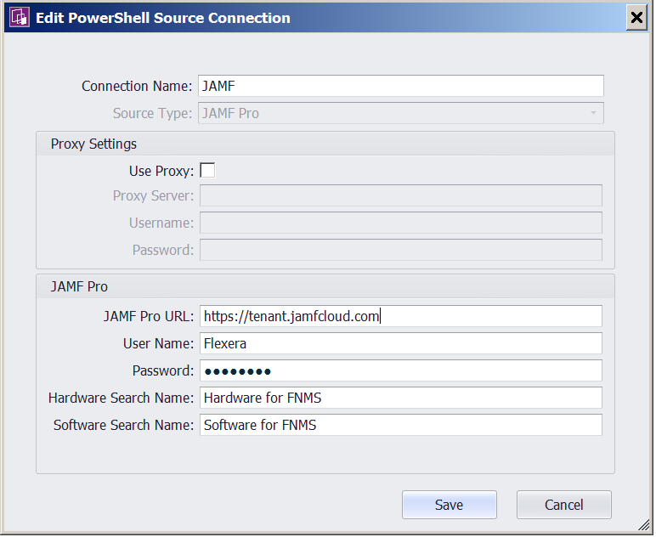

JAMF Pro URL: URL directly to the JAMF Pro tenant.
User Name: User Name for account in JAMF Pro with access to data and web services
Password: Password for account in JAMF Pro with access to data and web services
Hardware Search Name: Name of the Saved Search for Hardware as defined in the JAMF Pro Configuration Step.
Software Search Name: Name of the Saved Search for Software as defined in the JAMF Pro Configuration Step.

After the data is imported, you will see the Inventory data imported into FNMS.

Data Validation in FNMS

Where does the imported JAMF Pro data go?
Computers and related Software Installations may be found in Inventory.

Inventory
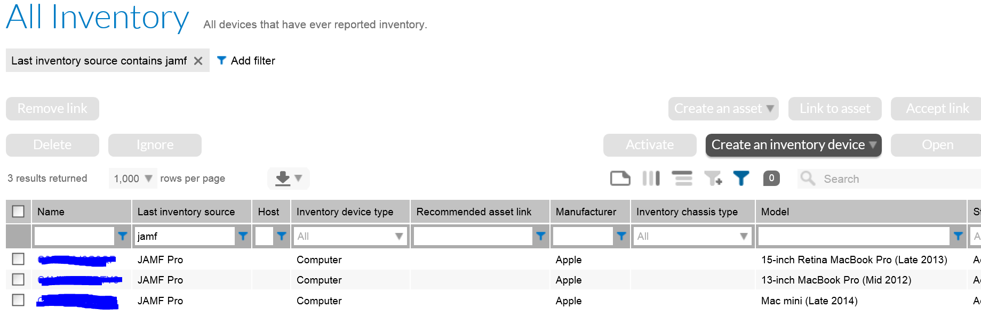

Installed Applications
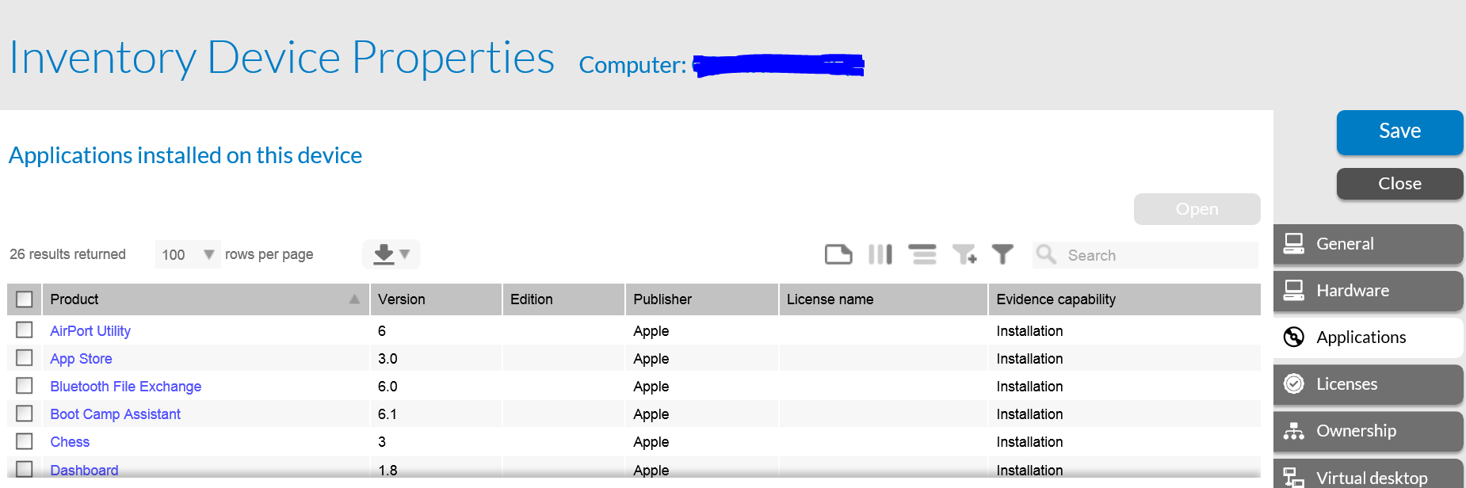

Appendix

JAMF Pro-FNMS Integration Data Flow

